**GARAGE MANAGEMENT SYSTEM**

**COLLEGE NAME : GOVERNMENT ARTS COLLEGE UDHAGAMANDALAM**

**COLLEGE CODE : BRU11**

**TEAM ID : NM2025TMID27265**

**TEAM MEMBERS : 4**

**TEAM LEADER : SHANIYA S P**

**EMAIL :** [**shaniyapoornan06@gmail**](mailto:shaniyapoornan06@gmail.com)

**TEAM MEMBER1 : SAMSON ANDREWS S**

**EMAIL :** [**samsonandrews26@gmail.com**](mailto:samsonandrews26@gmail.com)

**TEAM MEMBER2 : USMAN R**

**EMAIL :** [**usmanarman484@gmail.com**](mailto:usmanarman484@gmail.com)

**TEAM MEMBER3 : SANJAY B**

**EMAIL :** [**sanjay9626130259@gmail.com**](mailto:sanjay9626130259@gmail.com)

**1.INTRODUCTION**

**1.1 PROJECT OVERVIEW**

The Garage Management System is a Salesforce-based application designed to streamline the operations of automobile garages. It handles customer management, appointment booking, service tracking, billing, and feedback collection. By using Salesforce features like objects, flows, reports, and dashboards, the garage can improve efficiency, reduce manual work, and deliver better customer satisfaction.

**1.2 Purpose**

The main objective of this project is to enable garages to manage their daily operations effectively. It ensures:

* Faster booking and scheduling of services.
* Accurate records of customers and vehicles.
* Automated billing and quality check processes.
* Real-time dashboards for performance tracking.

This reduces manual errors, improves customer relationships, and helps the garage grow its business.

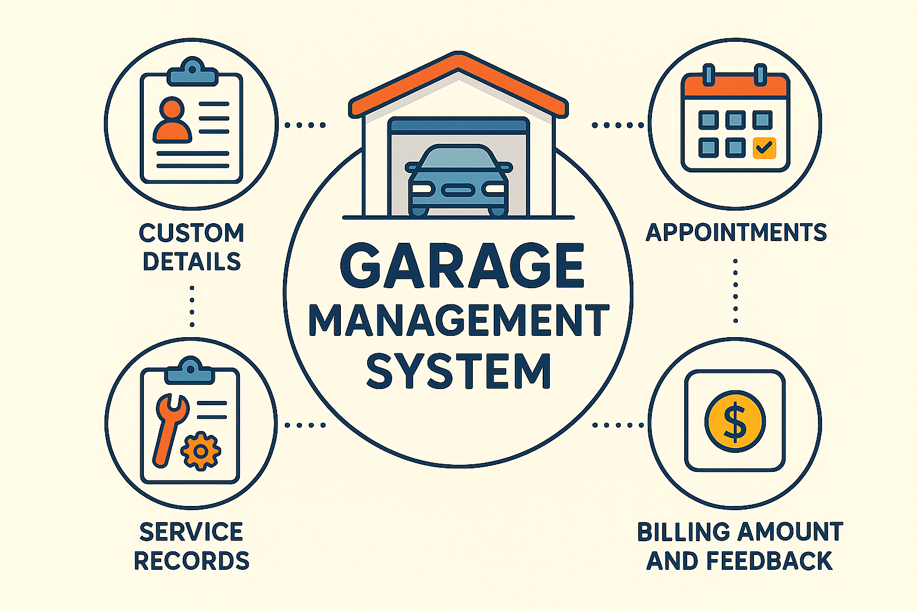

**2. DEVELOPMENT PHASE**

**2.1 Creating Developer Account**

A free Salesforce Developer Edition account was created to build and test the Garage Management System

Sign up using this link: <http://developer.salesforce.com/signup>

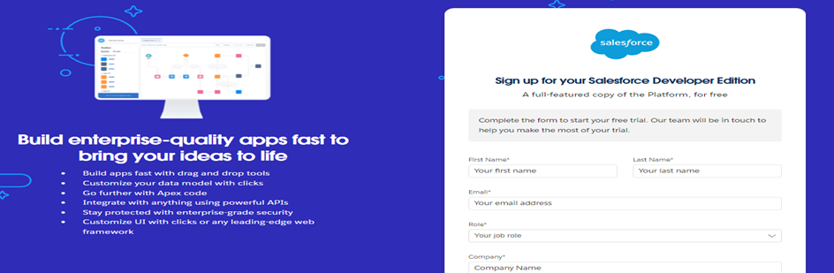

**3. Implementation/features**

**3.1 Custom Objects & Fields**

Custom objects were created in Salesforce to handle different parts of garage operations:

**1. Custom Objects**

**Customer:** Stores customer and vehicle details.

**Appointment:** Manages service booking and schedules.

**Service Record:** Tracks service type, status, and quality checks.

**Billing & Feedback:** Handles payments and customer reviews.

**Ensures every customer interaction is linked and trackable.**

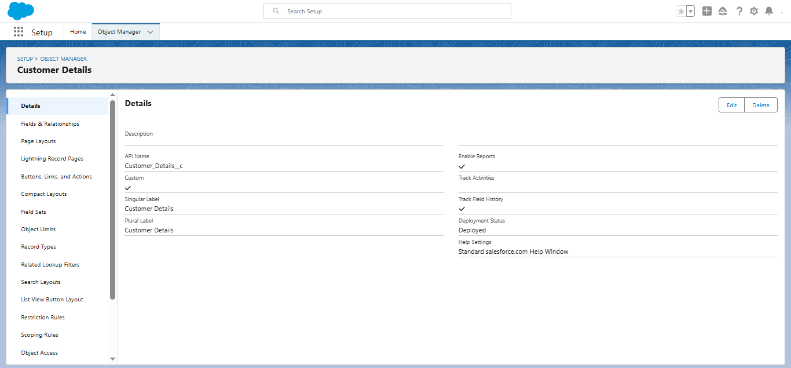

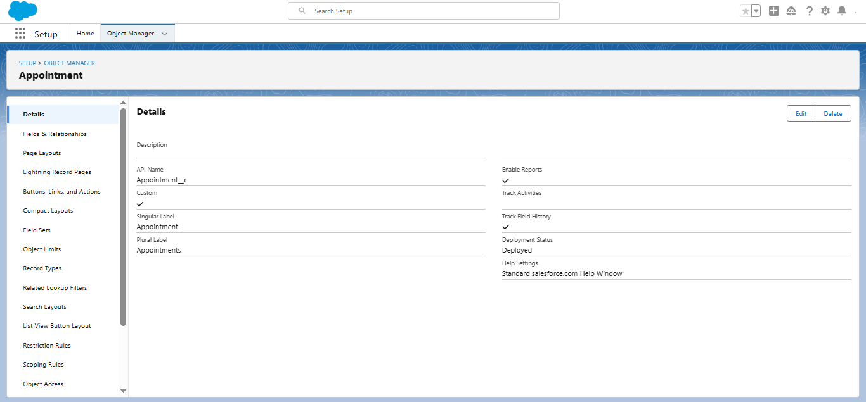

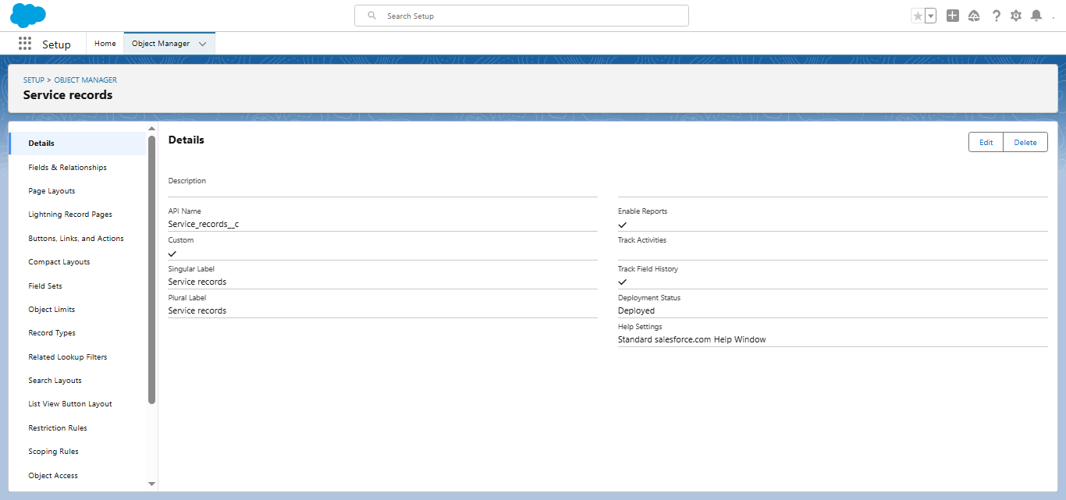

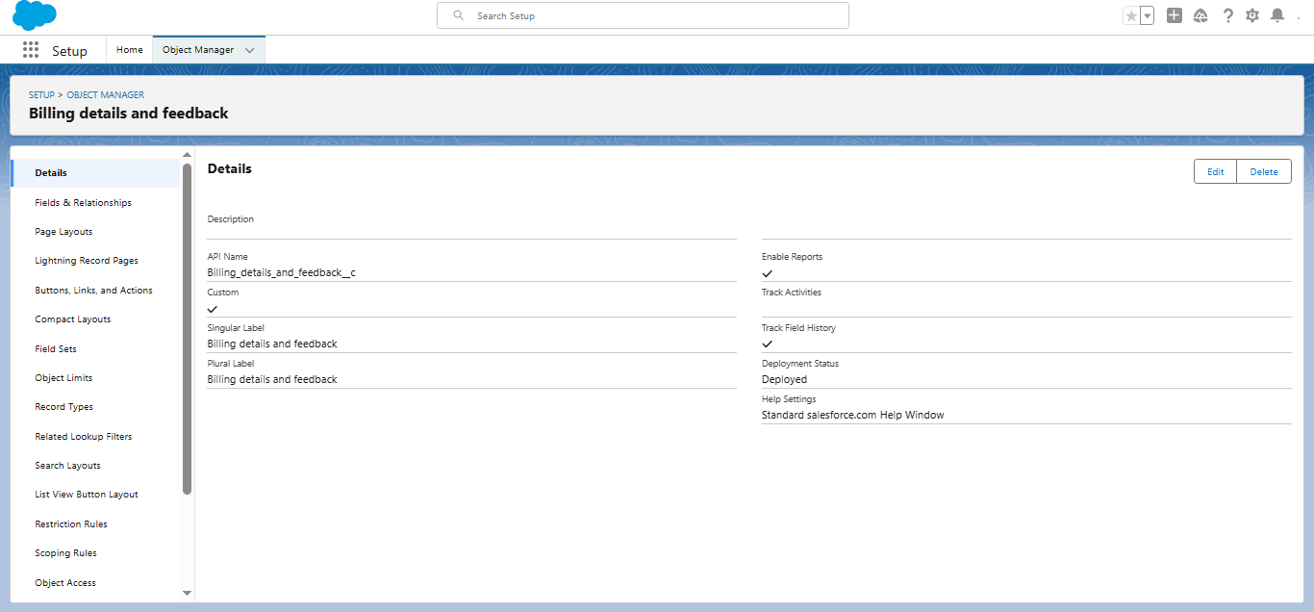

**3.2 Fields & Relationships**

Customer → Appointment → Service Record → Billing Amount & Feedback created as lookup relationships.

**Connects all garage processes in a single view.**

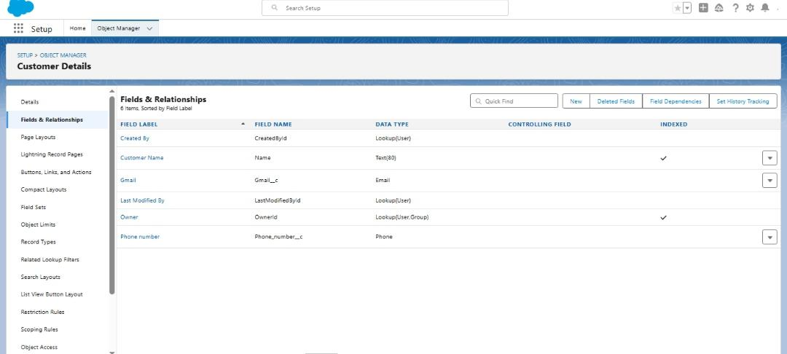

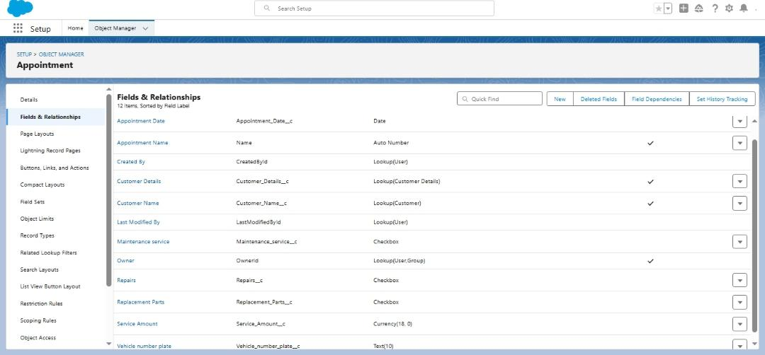

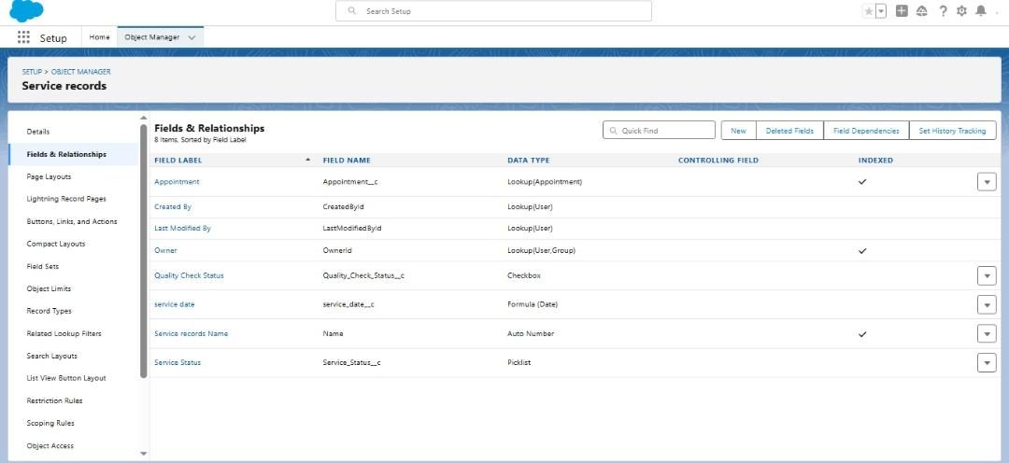

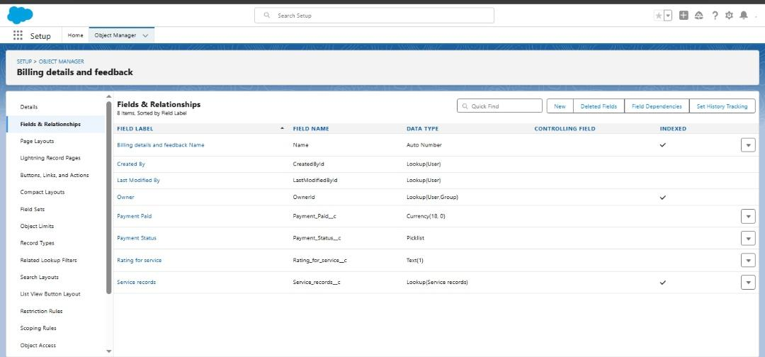

**3.3 Lightning App Development**

**Purpose:** A custom Garage Management Lightning App was created in Salesforce App Manager. Relevant custom objects such as Customer Details, Appointment, Service Record, Billing Amount and Feedback were added as navigation tabs.

**Provides a dedicated workspace for garage staff and managers to easily access all garage-related records in one place. This improves usability and avoids mixing with unrelated Salesforce standard apps.**

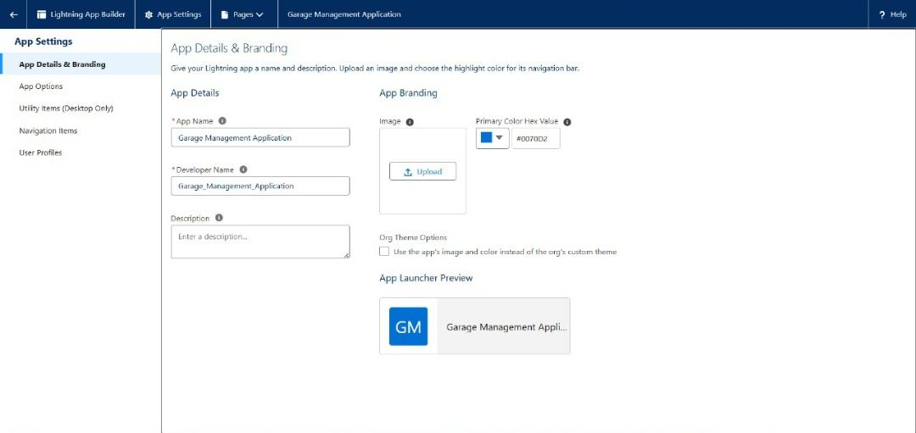

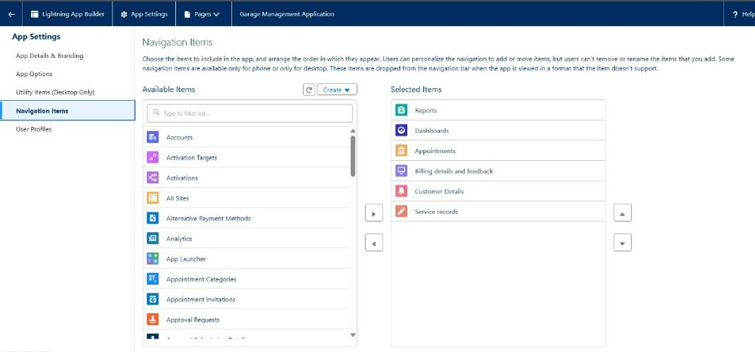

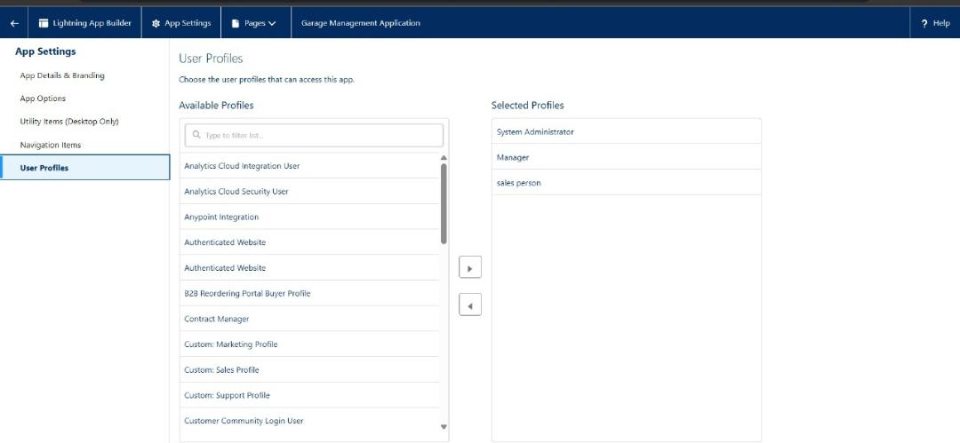

**3.4 Validation Rules**

**a) Appointment Validation Rule**

**Purpose:** Prevents users from creating appointments with a past date.

**Ensures that all service bookings are realistic and prevents scheduling errors.**

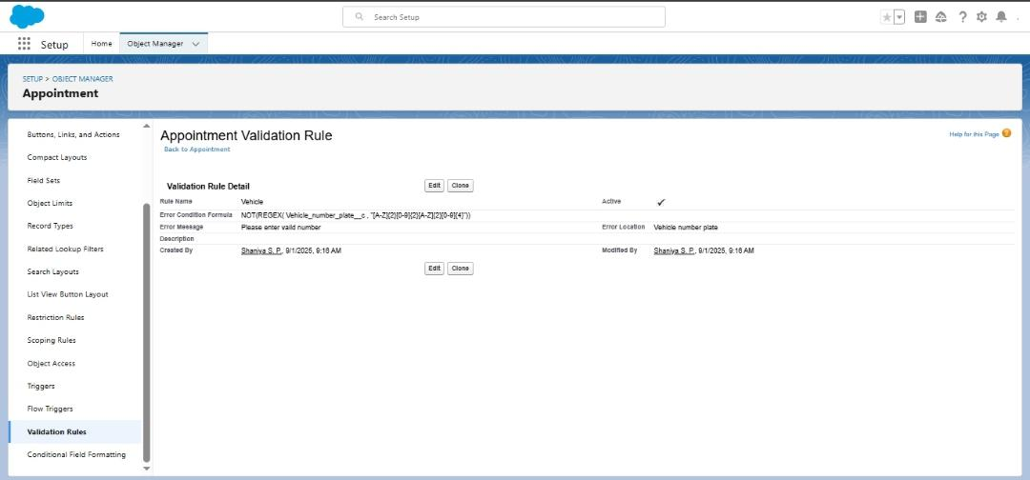

**b) Billing & Feedback Validation Rule**

**Purpose:** Ensures that a billing amount must be entered before saving the billing record and that customer feedback cannot be left blank for a completed service.

**Guarantees accurate financial records and makes sure customer feedback is always collected for quality improvement.**

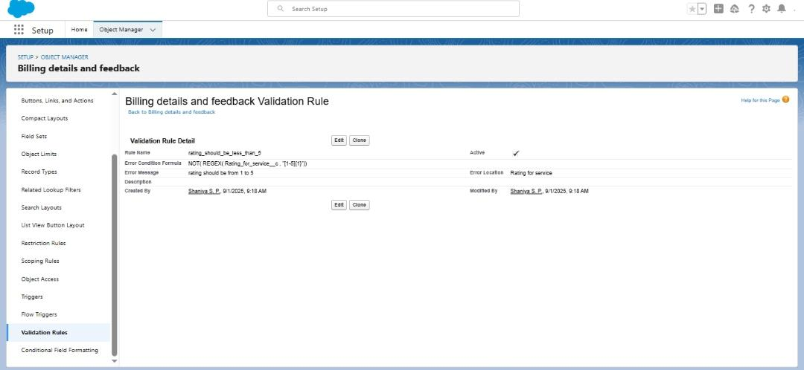

**3.5 Matching & Duplicate Rules**

**a) Matching Rule on Customer Details**

**Purpose:** A matching rule was created on the Customer Details object to identify duplicate records based on key fields such as Customer Name, Phone Number, or Email.

**Helps maintain clean and accurate customer data by detecting possible duplicate records**

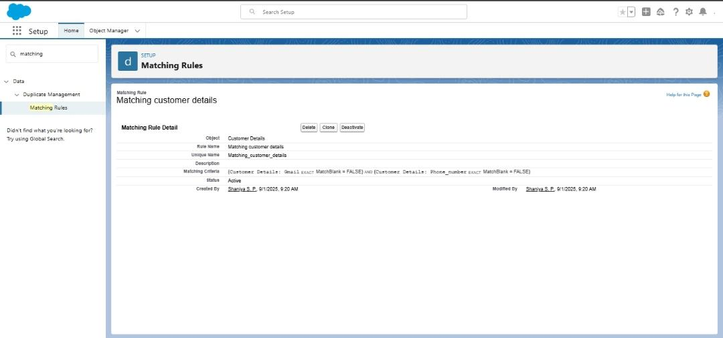

**b) Duplicate Rule on Customer Details**

**Purpose:** A duplicate rule was configured to block or warn users when they attempt to create a new customer record that matches an existing one.

**Prevents duplicate customer entries, avoids confusion, and improves the overall quality of customer data.**

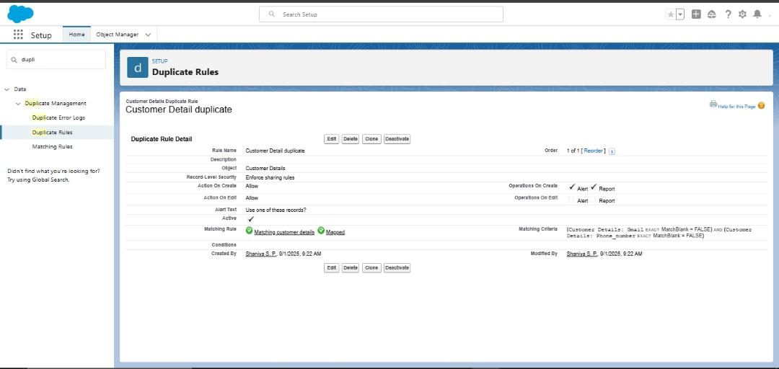

**3.6 Profiles & Permissions**

**a) Creating Profiles (Manager & Sales Person)**

**Purpose:** Two custom profiles — Manager and Sales Person — were created to control user access levels.

**Ensures that users only have access to the objects and records they need for their role, maintaining data security and proper responsibility division.**

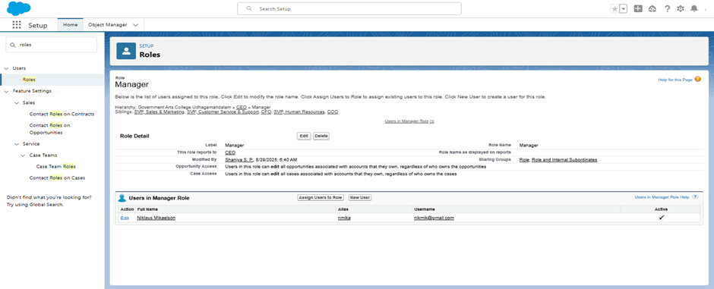

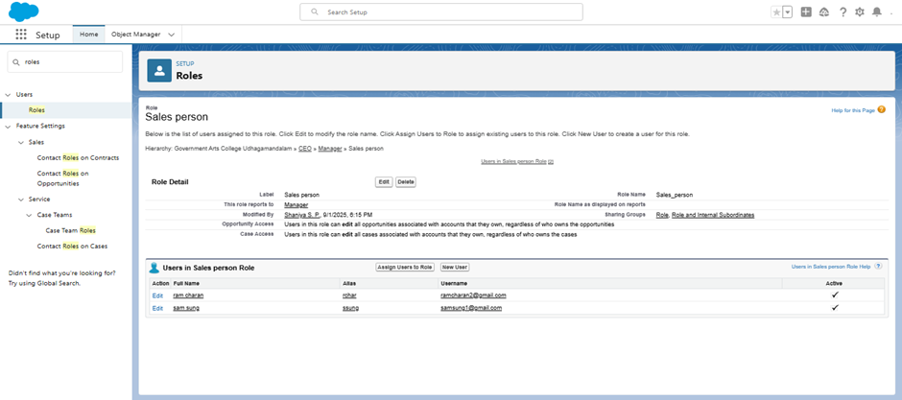

**b) Setting Garage Management App as Default**

**Purpose:** The custom Garage Management Lightning App was set as the default app for users with Manager and Sales Person profiles.

**Provides a consistent user experience by ensuring that when users log in, they directly access the garage-related CRM functions.**

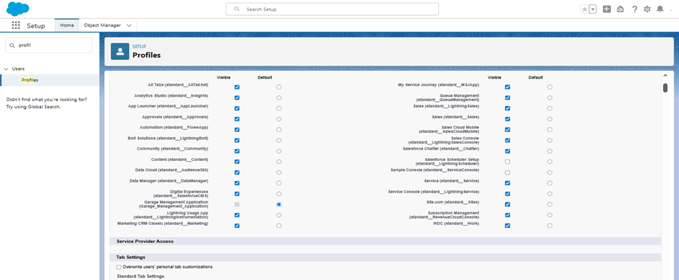

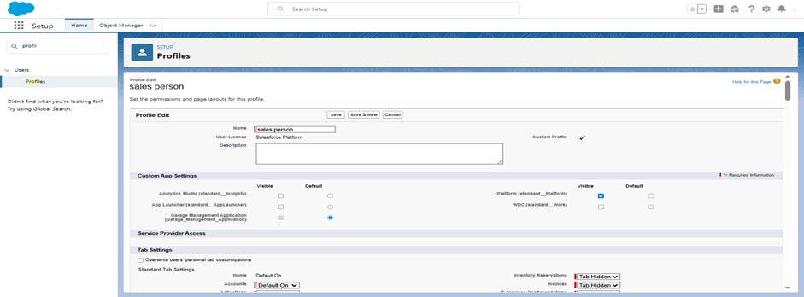

**c) Custom Object Permissions**

**Purpose**: Object-level permissions were assigned for Appointments, Billing & Feedback, Service Records, and Customer Details.

**Manager Profile:** Full access (Read, Edit, Delete, View All Records, Modify All, View All Fields).

**Sales Person Profile:** Limited access (Read).

**Controls who can view or modify garage data, protecting sensitive records while enabling staff to perform their tasks effectively.**

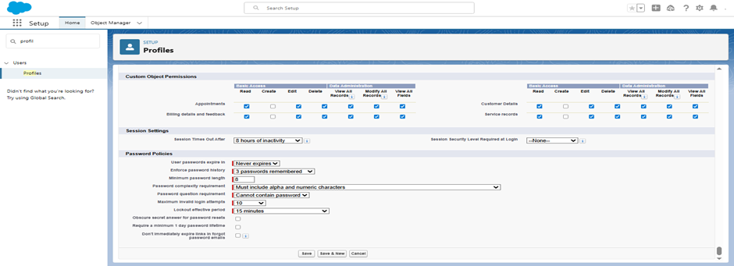

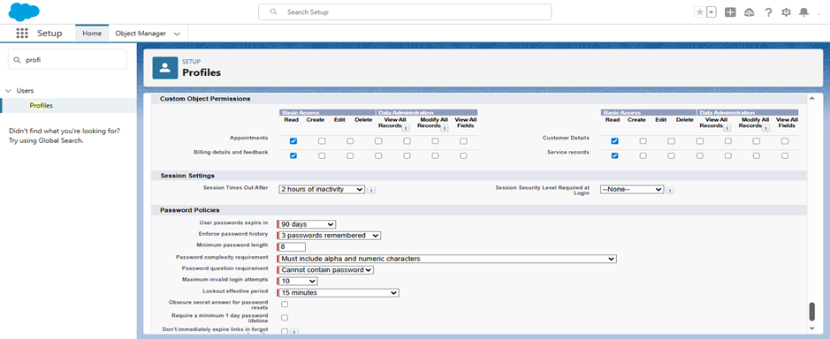

**3.7 User**

**a) Manager User**

**Details:** A user was created with the following configuration:

**Role:** Manager

**User License:** Salesforce

**Profile:** Manager

**Represents the garage manager who oversees all operations, with full system access.**

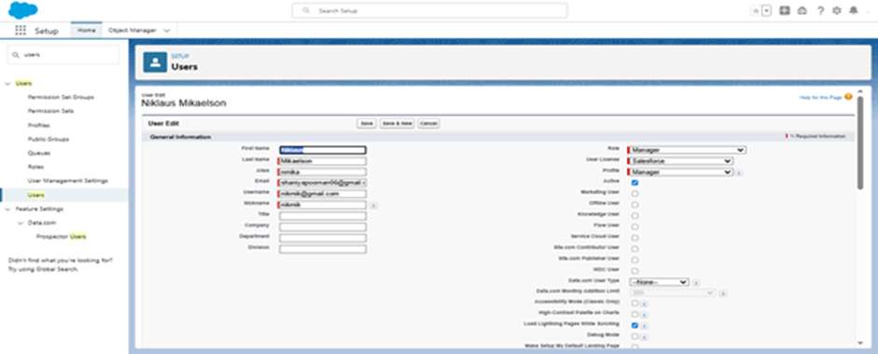

**b) Sales Person Users**

**Details:** Two users were created with the following configuration:

**Role:** Sales Person

**User License:** Salesforce Platform

**Profile:** Sales Person

**Represents sales staff responsible for handling customer bookings and service records, with restricted access compared to the Manager.**

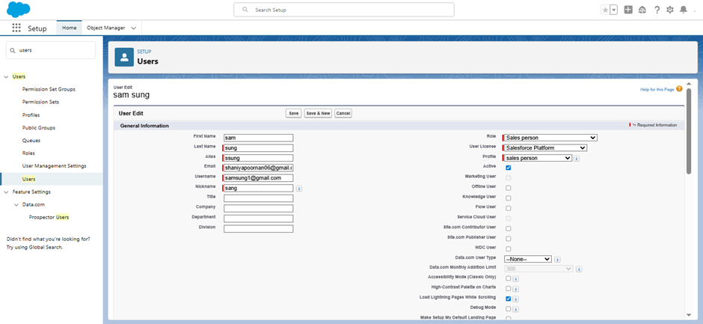

**3.8 Public Group**

**a) Creating a Public Group**

**Purpose:** A new public group named sales team was created, including users from the Sales Person roles.

**Simplifies the process of assigning record access and sharing rules to multiple users at once**

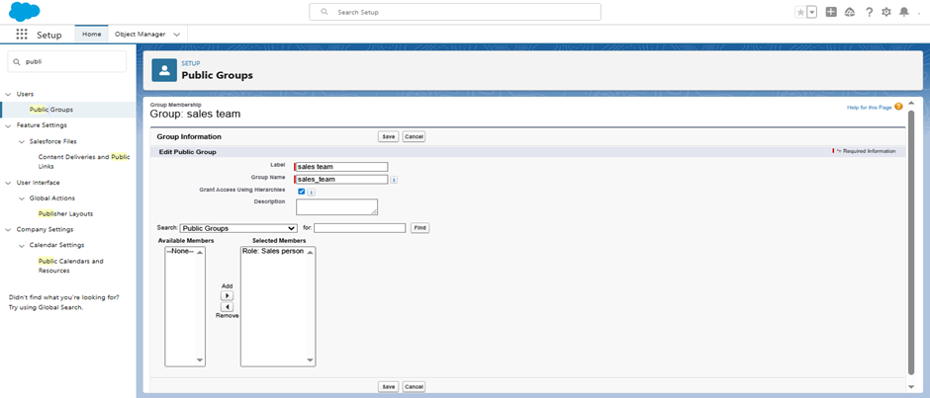

**b) Sharing Settings for Service Records**

**Purpose:** Organization-Wide Defaults (OWD) were configured to Private for the Service Record object. A sharing rule was then applied to share service records with the sales team group.

**Ensures that only authorized sales team can view and edit service records. This provides security for sensitive service data while still allowing collaboration between managers and sales persons.**

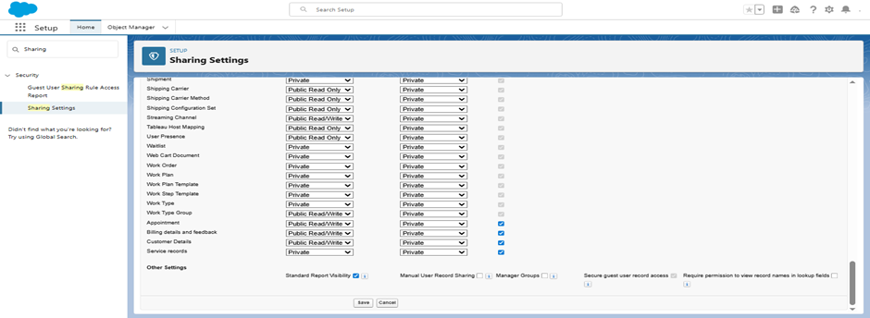

**3.8 Flows**

**a)Record-Triggered Flow for Billing & Feedback**

**Flow Name:** Billing Amount Flow

**Details:** A Record-Triggered Flow was created on the Billing Details and Feedback object.

**Trigger:** When a billing record is created or updated.

**Logic:** Updates the billing amount field automatically.

Sends an email alert to notify the customer or manager.

**Automates billing updates and notifications, reduces human errors, and keeps customers informed promptly about their billing details.**

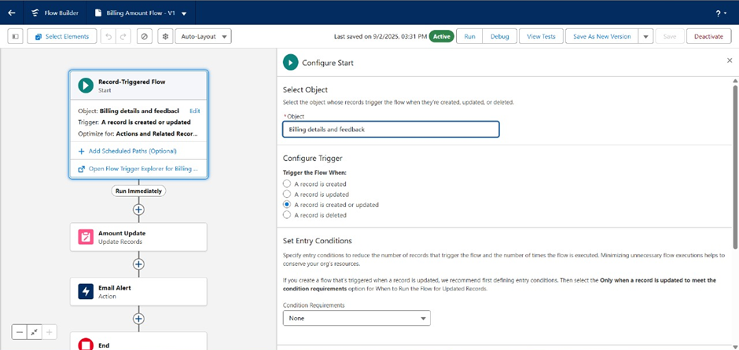

**b) Record-Triggered Flow for Service Records**

**Flow Name:** Update Service Status

**Details:** A Record-Triggered Flow was created on the Service Records object.

**Trigger:** When a Service Record is created or updated.

**Logic:** Automatically updates the service status field to Completed.

**Reduces manual work, ensures accuracy, and speeds up service tracking.**

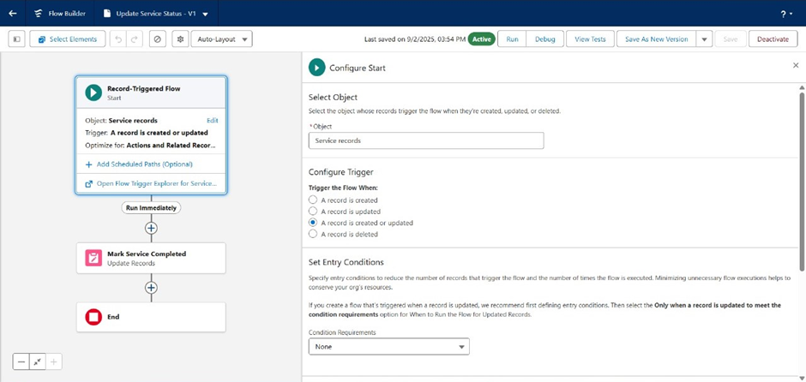

**3.9 Apex**

**a) Apex Handler Class – AmountDistributionHandler**

**Details:** An Apex handler class named AmountDistributionHandler was created.

**Purpose:** To contain the business logic for distributing the total appointment amount across all related service records.

**Separating logic into a handler class improves maintainability, reusability, and follows best practices in Salesforce development.**

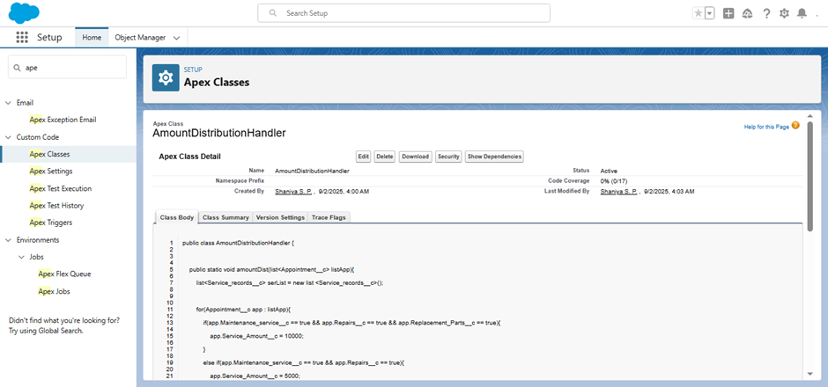

**b) Apex Trigger – AmountDistribution**

**Details:** An Apex Trigger named AmountDistribution was created on the Appointment__c object.

**Purpose:** Executes after an appointment record is inserted or updated, calling the handler to distribute the total appointment amount to related service records.

**Automates financial consistency — ensures that whenever an appointment is created or updated, the related service records automatically reflect accurate distributed amounts.**

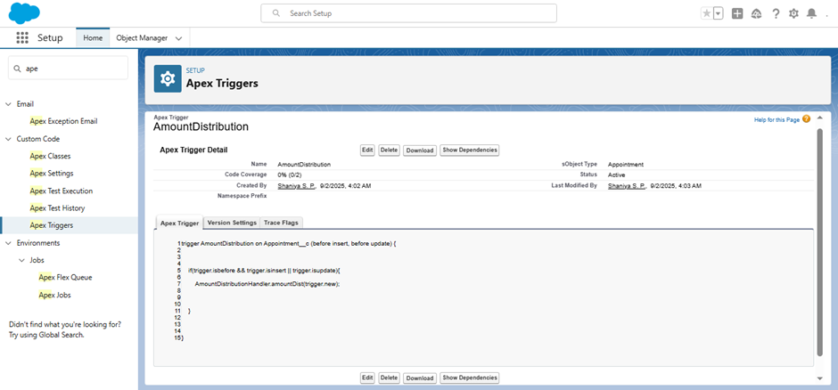

**3.10 Reports**

**a) Creating Report Folder**

**Details:** A new Report Folder was created and named Garage Management Folder.

**Purpose:** To organize all reports related to the Garage Management System (Appointments, Service Records, Billing, Feedback).

**Keeps reports structured and accessible for managers and sales staff, making it easier to track garage operations.**

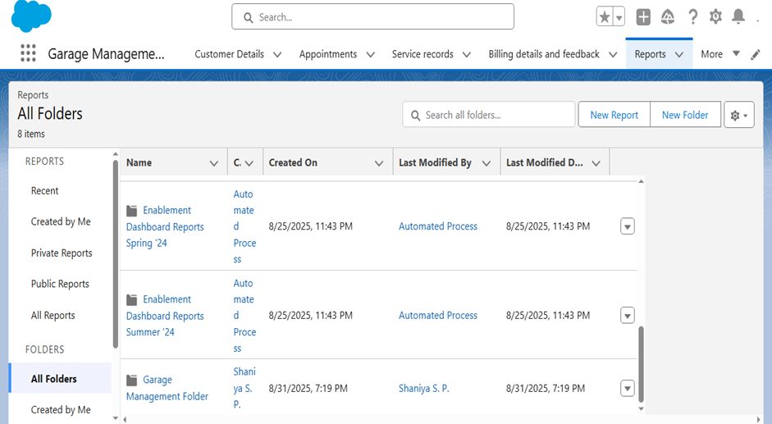

**b) Sharing a Report Folder**

**Details:** The Garage Management Folder was shared with the Garage Staff Public Group.

**Purpose:** Ensures that both Managers and Sales Persons can access reports.

**Provides transparency across the team while maintaining controlled access.**

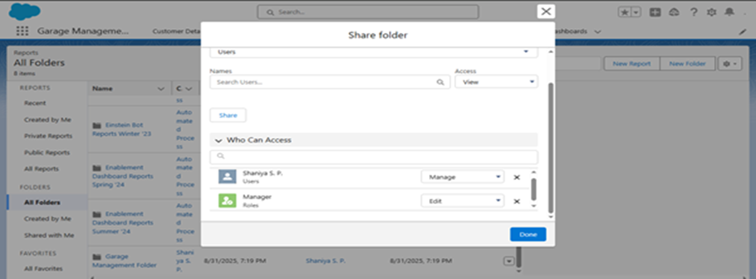

**c) Creating a Custom Report Type**

**Details:** A Custom Report Type was created for Appointments with related Service Records.

**Purpose:** Allows reports to combine data from multiple related objects (e.g., Customers, Appointments, Services).

**Enables deeper analysis, such as which services are most frequently booked per customer.**

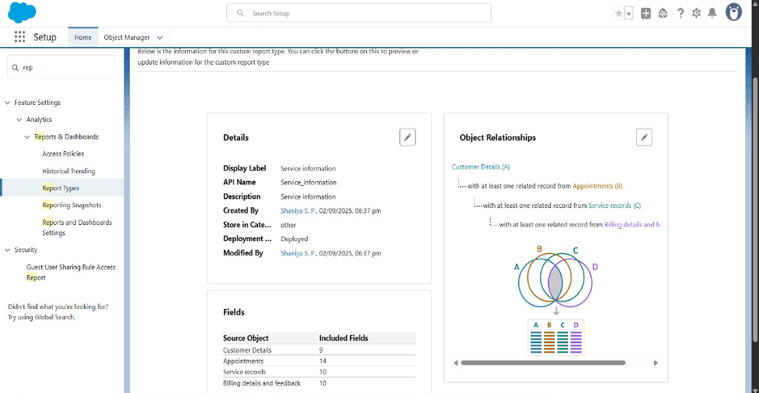

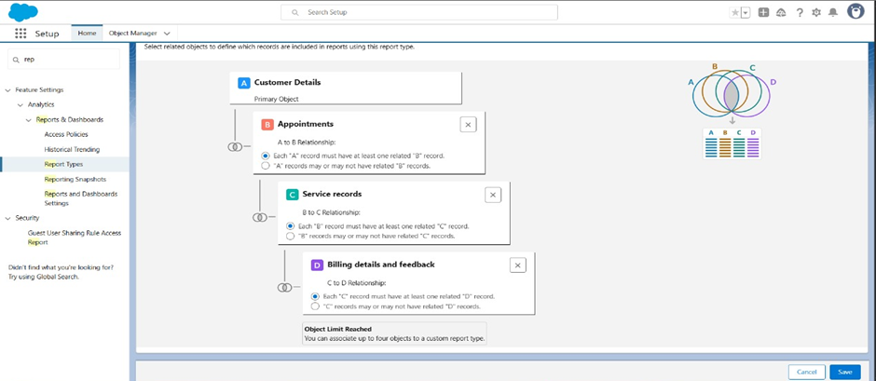

**d) Creating Reports**

**Reports Created:**

**1. Service Records Report –** shows the latest 10 service records with status updates.

**2. Billing & Feedback Report –** tracks billing amounts, payment status, and customer ratings.

**3. Appointments Report –** lists upcoming and completed appointments with assigned customers.

**4. Customer Details Report –** includes key customer information such as name, contact, and related appointment history.

**Service Records Report → Helps track operational workflow.**

**Billing & Feedback Report → Ensures financial monitoring and quality control.**

**Appointments Report → Gives managers visibility into scheduling.**

**Customer Details Report → Centralizes customer information for managers and sales persons, allowing better relationship management.**

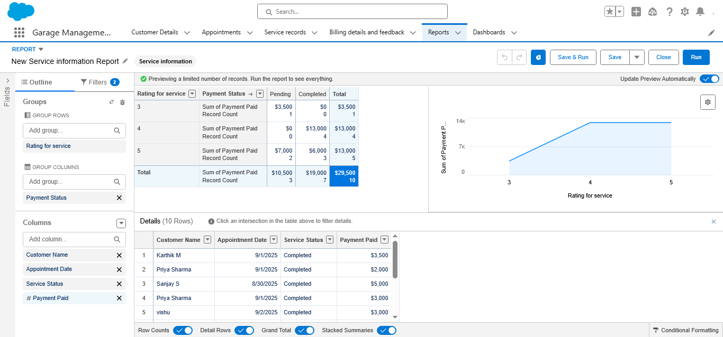

**3.11 Dashboards**

**a) Creating a Dashboard Folder**

**Details:** A new Dashboard Folder named Garage Management Dashboards was created.

**Purpose:** To organize and store dashboards separately from reports.

**Ensures dashboards are easily accessible and shareable with the garage team.**

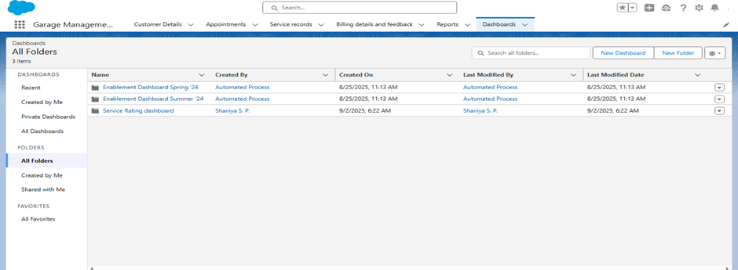

**b) Creating a Dashboard**

**Details:** A new dashboard named Garage Management Dashboard was created inside the folder.

**Components Used:**

**1. Service Status Chart –** Pie chart showing distribution of service statuses (None, Started, Completed).

**2. Billing Summary –** Bar chart comparing total paid vs pending payments.

**3. Appointments Overview –** Line graph showing scheduled vs completed appointments over time.

**4. Customer Feedback –** Gauge chart displaying average customer ratings.

**Provides managers with a quick visual overview of operations, financial performance, and customer satisfaction in one place.**

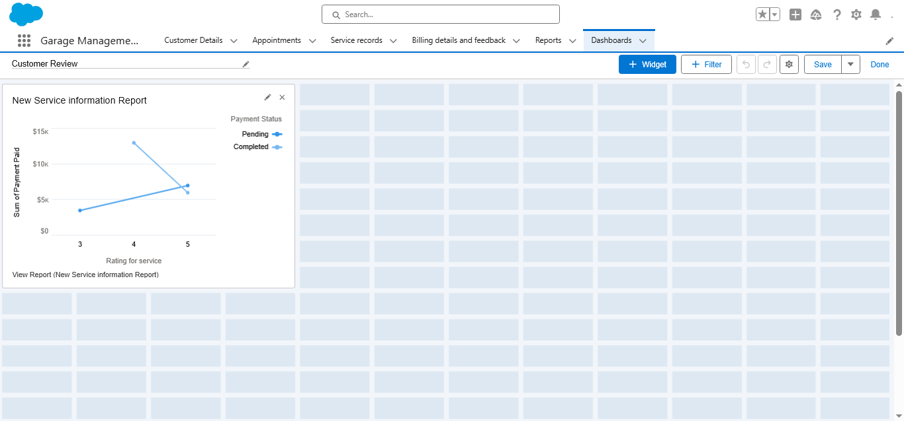

**4. TESTING APPROCH**

In this project, testing was carried out to make sure all Salesforce components worked correctly:

* **Validation Rules →** Tested by entering invalid data (blank appointment date, wrong vehicle number) and checking that error messages appeared.
* **Duplicate Rules →** Tested by creating a customer with the same email/phone to ensure a duplicate warning was shown.
* **Flows →** Verified that when a Service Record was created, related Billing & Feedback records were generated automatically.
* **Reports & Dashboards →** Checked by running reports to confirm service and billing details displayed correctly.

**This ensured data accuracy, working automation, and clear error handling for users.**

**5. Output – Garage Management System**

The Garage Management CRM demonstrates how Salesforce features streamline garage operations. Key outputs are:

**5.1 Custom App & Navigation**

A dedicated Garage Management App was created with tabs (Customer Details, Appointments, Service Records, Billing Amount & Feedback).

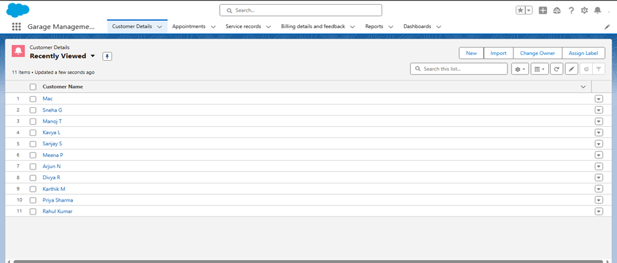

**5.2 Custom Objects & Relationships**

Objects are linked so managers can navigate from a customer record to related appointments, service records, and billing amount and feedback.

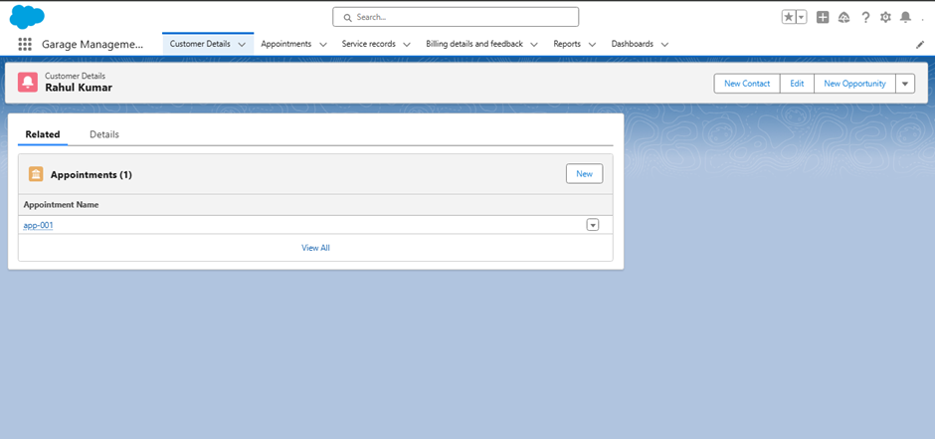

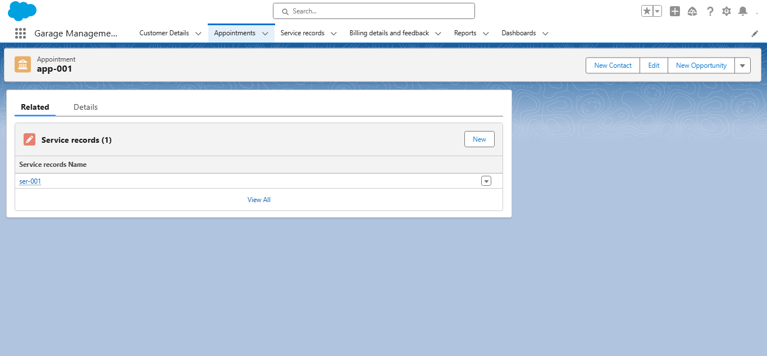

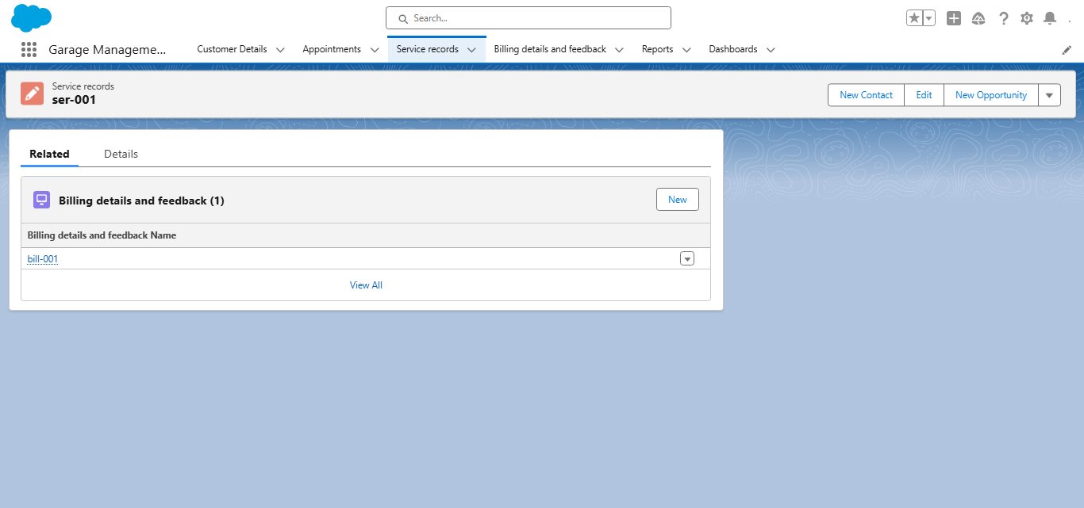

**5.3 Validation Rules**

* **Vehicle Number Plate →** Prevents invalid formats (shows error “Please enter valid number”).

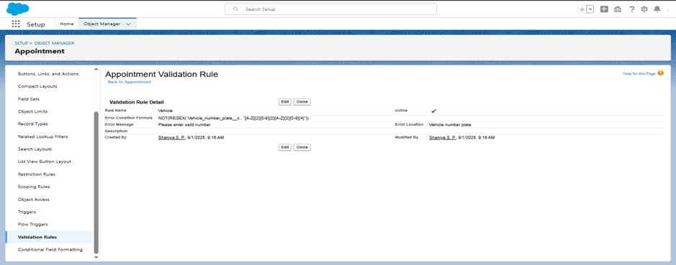

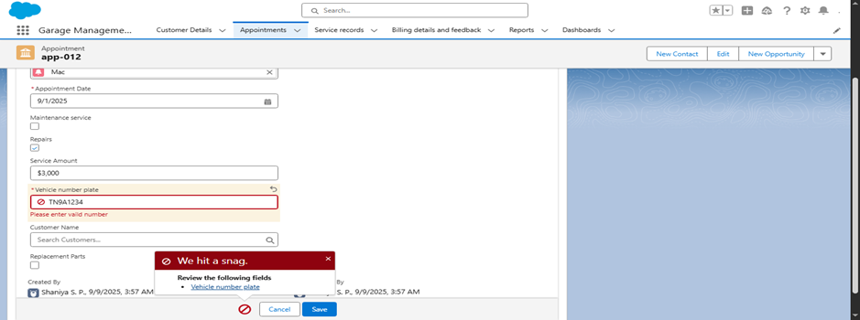

* **Billing Rating** → Restricts feedback ratings to 1–5.

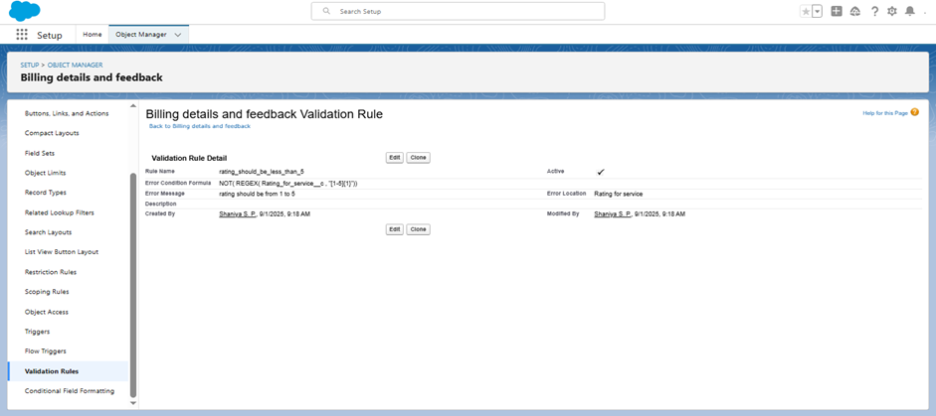

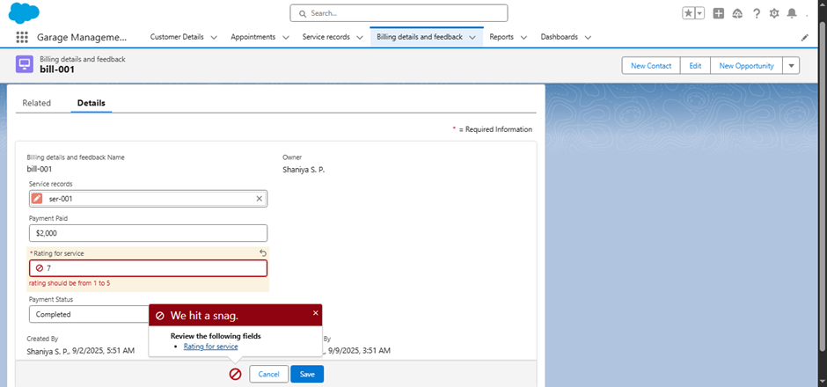

**5.4 Duplicate & Matching Rules**

A Matching Rule on email/phone alerts users when duplicate customer details are entered.

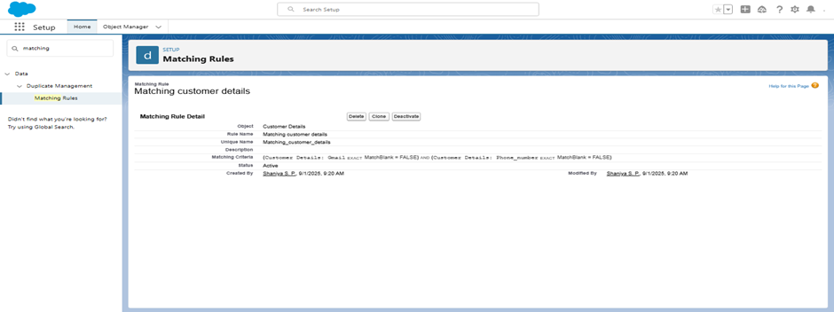

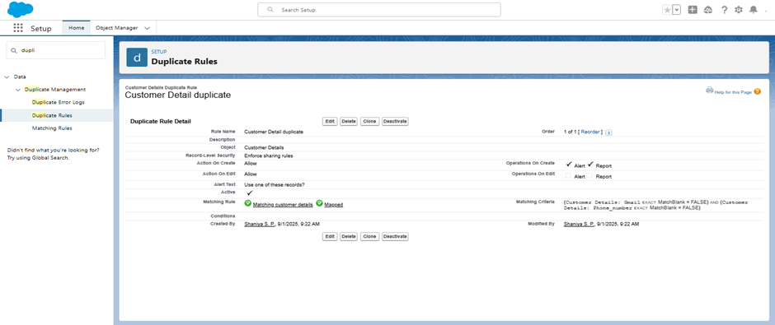

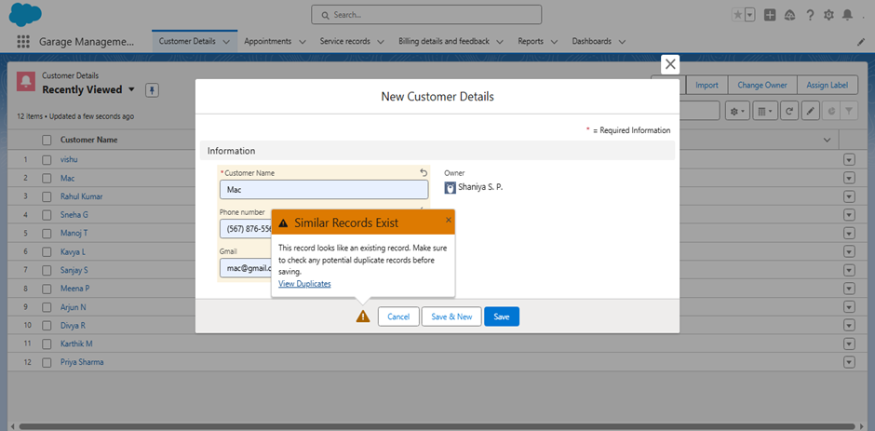

**5.5 Public Group & Sharing Settings**

A Public Group (Sales Team) was created. Sharing Rule ensures Service Records created by Sales Persons are shared with Managers.



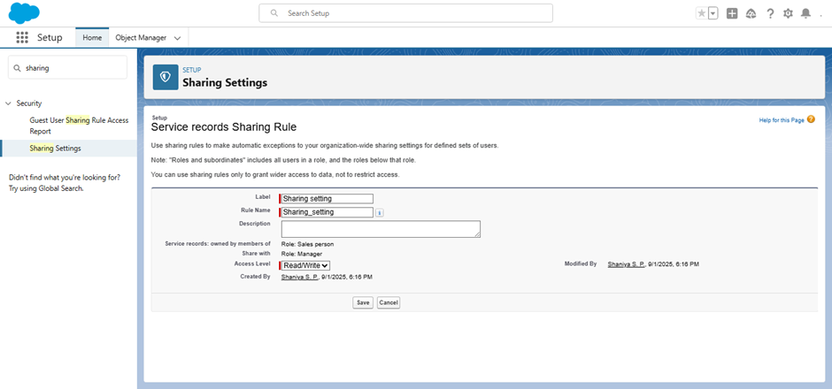

**5.6 Flows & Automation**

* **Billing & Feedback Flow →** Auto-calculates billing and creates feedback after payment.

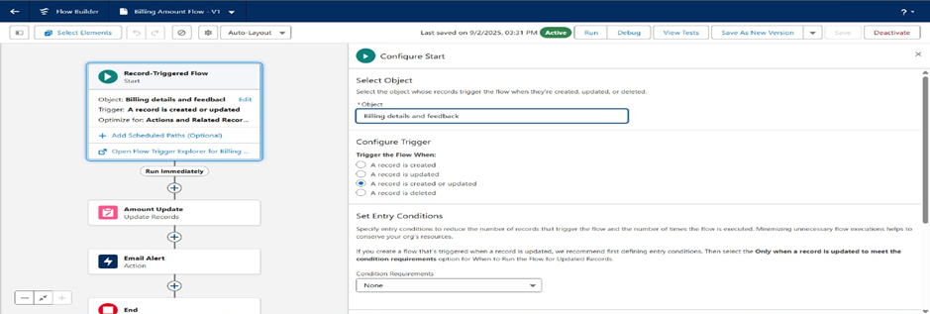

* **Service Record Flow →** Creates Service Record automatically when an Appointment is confirmed.

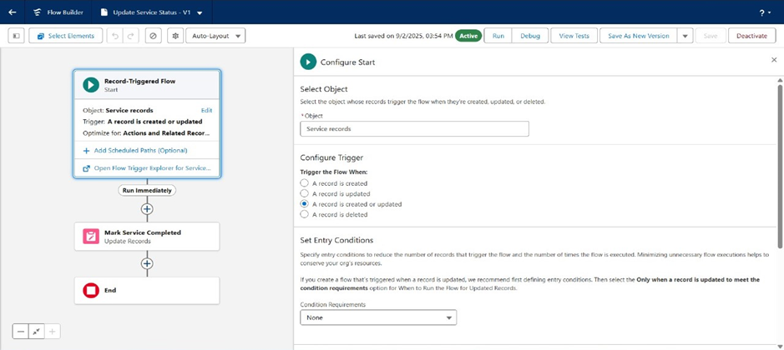

**5.7 Apex Trigger & Handler**

An Apex Trigger **(AmountDistribution)** and a Handler class **(AmountDistributionHandler)** were created on the Appointment object.

This automation improves efficiency by reducing human error in payment calculations.

Apex Handler class **(AmountDistributionHandler)**

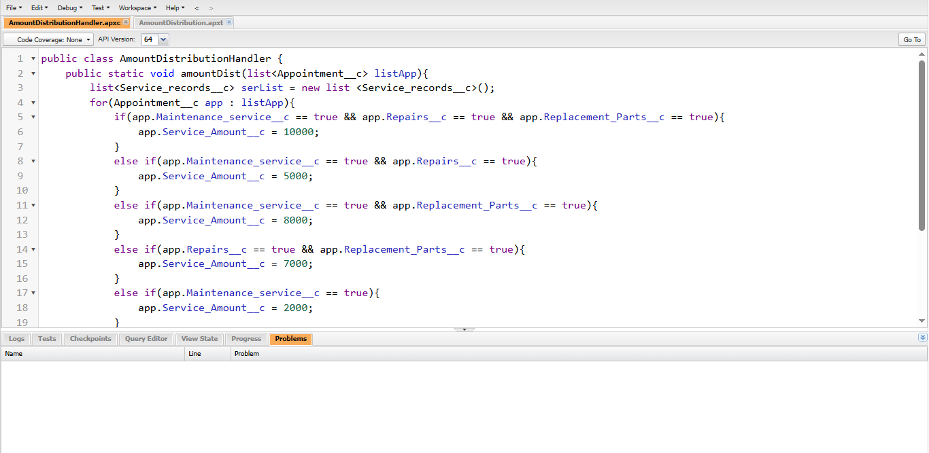

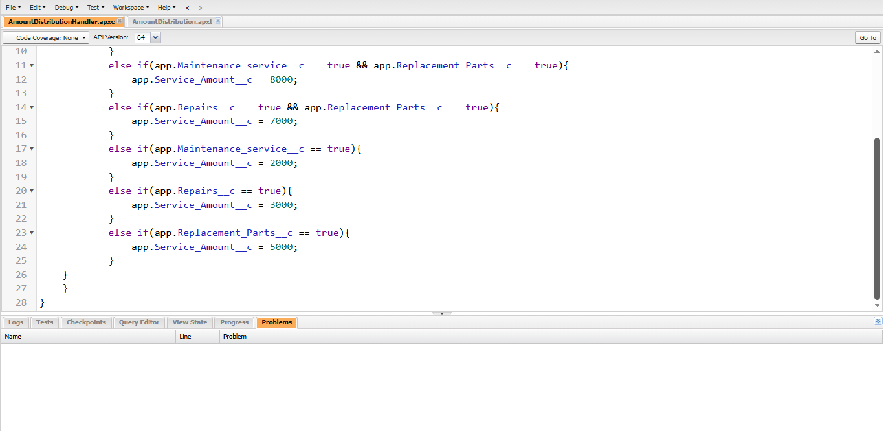

**Code:**

public class AmountDistributionHandler {

public static void amountDist(list<Appointment__c> listApp){

list<Service_records__c> serList = new list <Service_records__c>();

for(Appointment__c app : listApp){

if(app.Maintenance_service__c == true && app.Repairs__c == true && app.Replacement_Parts__c == true){

app.Service_Amount__c = 10000;

}

else if(app.Maintenance_service__c == true && app.Repairs__c == true){

app.Service_Amount__c = 5000;

}

else if(app.Maintenance_service__c == true && app.Replacement_Parts__c == true){

app.Service_Amount__c = 8000;

}

else if(app.Repairs__c == true && app.Replacement_Parts__c == true){

app.Service_Amount__c = 7000;

}

else if(app.Maintenance_service__c == true){

app.Service_Amount__c = 2000;

}

else if(app.Repairs__c == true){

app.Service_Amount__c = 3000;

}

else if(app.Replacement_Parts__c == true){

app.Service_Amount__c = 5000;

}

}

}

}

Apex Trigger **(AmountDistribution)**

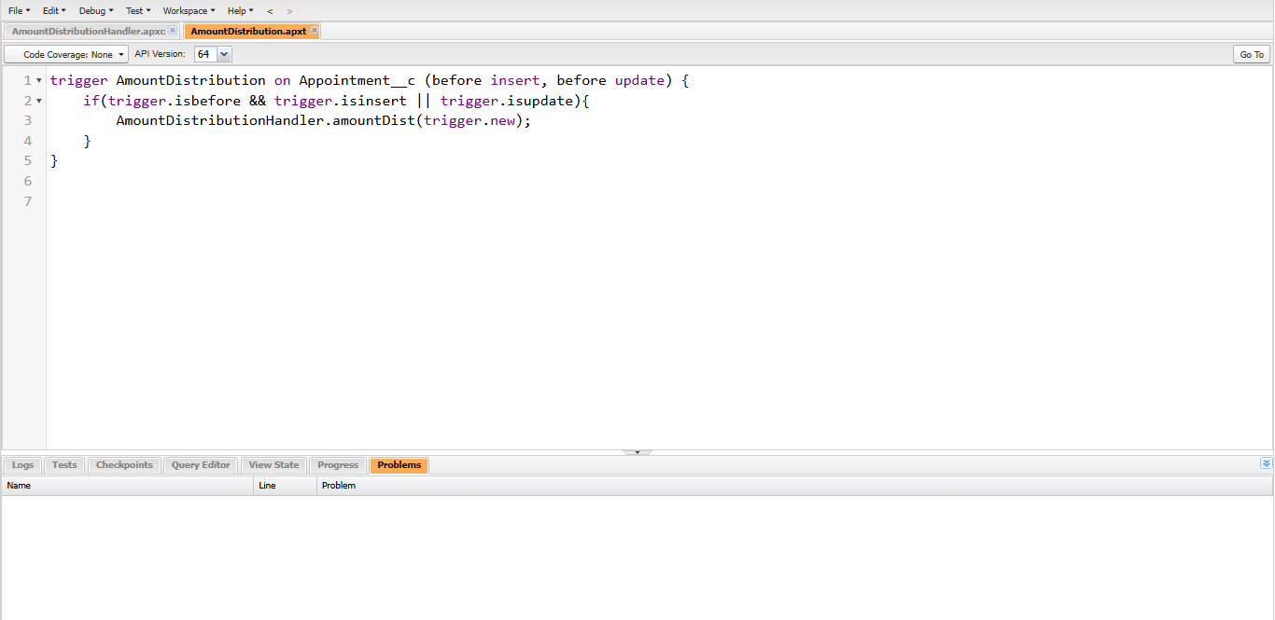

**Code:**

trigger AmountDistribution on Appointment__c (before insert, before update) {

if(trigger.isbefore && trigger.isinsert || trigger.isupdate){

AmountDistributionHandler.amountDist(trigger.new);

}

}

**5.8 Reports & Dashboards**

Reports display Service Records, Billing, and Feedback. Dashboards show service progress, billing summary, and customer satisfaction.





**6. Future Enhancements**

In the future, this Garage Management System can be improved with more smart features. For example, customers could book appointments through a chatbot, or pay their bills directly online. The system can also send automatic service reminders using AI, and maybe even have a mobile app for garage staff to update records quickly. A self-service portal for customers would also make the experience easier and faster.

**7. Conclusion**

This project helped build a Garage Management System on Salesforce that makes daily garage work easier. From managing customers and appointments to billing and feedback, everything is connected in one place. The validation rules, automation flows, reports, and dashboards make the system reliable and efficient. Overall, the project shows how Salesforce can be customized to solve real business problems and improve customer service.